Log Book | Group 2
Datasheets
LTL-4221N
ZTX458
74HC585N
74LS04N
74LS138N
WEEK 2 - January 16 - January 22, 2022
PATTERN A
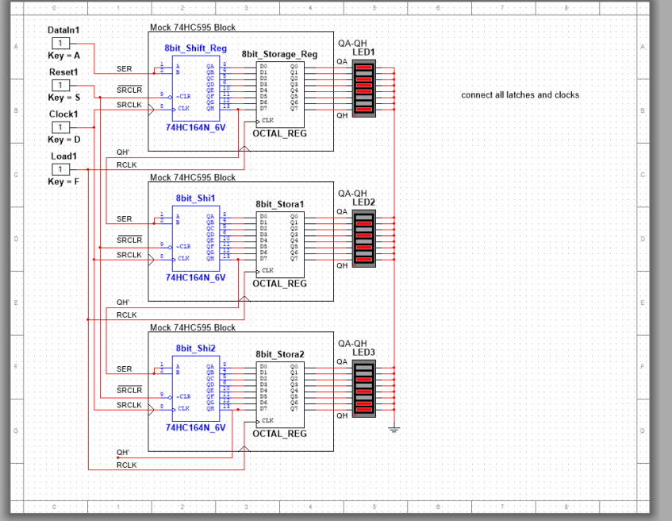
PATTERN B
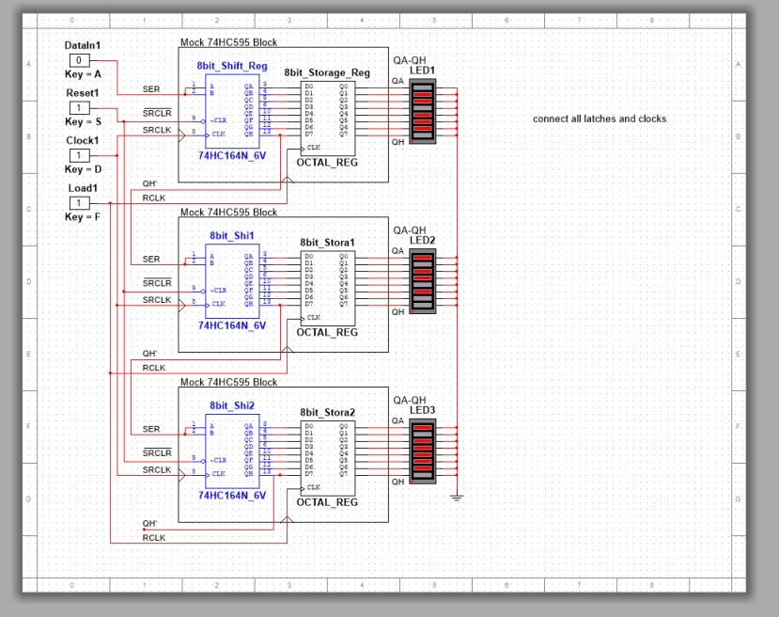
TIMING DIAGRAMS
Pattern 1:
Data In | 1 | 1 | 1 | 1 | 0 | 0 | 1 | 1 | 0 | 0 | 1 | 1 | 0 | 0 | 0 | 0 | 1 | 1 | 0 | 0 | 1 | 1 | 0 | 0
Reset | 1 | 1 | 1 | 1 | 1 | 1 | 1 | 1 | 1 | 1 | 1 | 1 | 1 | 1 | 1 | 1 | 1 | 1 | 1 | 1 | 1 | 1 | 1 | 1
Clock | 0 | 1 | 0 | 1 | 0 | 1 | 0 | 1 | 0 | 1 | 1 | 0 | 1 | 0 | 1 | 0 | 1 | 0 | 1 | 1 | 0 | 1 | 0 | 1
Load | 0 | 0 | 0 | 0 | 0 | 0 | 0 | 0 | 0 | 0 | 0 | 0 | 0 | 0 | 0 | 0 | 0 | 0 | 0 | 0 | 0 | 0 | 0 | 0

Data In | 1 | 1 | 0 | 0 | 1 | 1 | 0 | 0 | 1 | 1 | 0 | 0 | 0 | 0 | 1 | 1 | 1 | 1 | 1 | 1 | 0 | 0 | 1 | 1
Reset | 1 | 1 | 1 | 1 | 1 | 1 | 1 | 1 | 1 | 1 | 1 | 1 | 1 | 1 | 1 | 1 | 1 | 1 | 1 | 1 | 1 | 1 | 1 | 1
Clock | 0 | 1 | 0 | 1 | 0 | 1 | 0 | 1 | 0 | 1 | 1 | 0 | 1 | 0 | 1 | 0 | 1 | 0 | 1 | 1 | 0 | 1 | 0 | 1
Load | 0 | 0 | 0 | 0 | 0 | 0 | 0 | 0 | 0 | 0 | 0 | 0 | 0 | 0 | 0 | 0 | 0 | 0 | 0 | 0 | 0 | 0 | 0 | 1

Pattern 2:
Data In | 0 | 0 | 1 | 1 | 1 | 1 | 1 | 1 | 1 | 1 | 1 | 1 | 0 | 0 | 1 | 1 | 0 | 0 | 0 | 0 | 1 | 1 | 0 | 0
Reset | 1 | 1 | 1 | 1 | 1 | 1 | 1 | 1 | 1 | 1 | 1 | 1 | 1 | 1 | 1 | 1 | 1 | 1 | 1 | 1 | 1 | 1 | 1 | 1
Clock | 0 | 1 | 0 | 1 | 0 | 1 | 0 | 1 | 0 | 1 | 1 | 0 | 1 | 0 | 1 | 0 | 1 | 0 | 1 | 1 | 0 | 1 | 0 | 1
Load | 0 | 0 | 0 | 0 | 0 | 0 | 0 | 0 | 0 | 0 | 0 | 0 | 0 | 0 | 0 | 0 | 0 | 0 | 0 | 0 | 0 | 0 | 0 | 0

Data In | 1 | 1 | 1 | 1 | 0 | 0 | 1 | 1 | 0 | 0 | 1 | 1 | 1 | 1 | 1 | 1 | 0 | 0 | 1 | 1 | 1 | 1 | 0 | 0
Reset | 1 | 1 | 1 | 1 | 1 | 1 | 1 | 1 | 1 | 1 | 1 | 1 | 1 | 1 | 1 | 1 | 1 | 1 | 1 | 1 | 1 | 1 | 1 | 1
Clock | 0 | 1 | 0 | 1 | 0 | 1 | 0 | 1 | 0 | 1 | 1 | 0 | 1 | 0 | 1 | 0 | 1 | 0 | 1 | 1 | 0 | 1 | 0 | 1
Load | 0 | 0 | 0 | 0 | 0 | 0 | 0 | 0 | 0 | 0 | 0 | 0 | 0 | 0 | 0 | 0 | 0 | 0 | 0 | 0 | 0 | 0 | 0 | 1

ROW CONTROL CIRCUIT (Had issues)
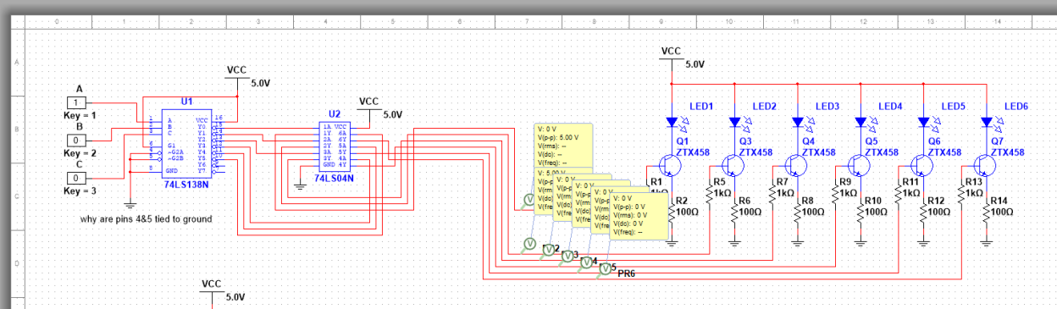
For some reason, despite the transistors getting 5V the LEDs would not turn on. Despite this issue we are confident that this circuit would work if applied.

Can you still produce the designated LED pattern?
When we discussed this, we both agreed that you could sort of. Although you couldn’t display the pattern ESE at once, due to the refresh rate of the human eye and the speed at which you can turn on and off the individual LEDS we theorized that you could most likely trick the brain into perceiving the pattern as desired with some clever programming of the display.

Week 3 - January 23 - January 29, 2022

For the row control our original plan was to have a 2-D array holding all the information of the ESE! output but we found that approach to be too inefficient, after brainstorming and taking another look at the pattern we noticed that some of the rows had the same pattern and that instead of storing information for 6 different rows we only need to store 3 unique row patterns.
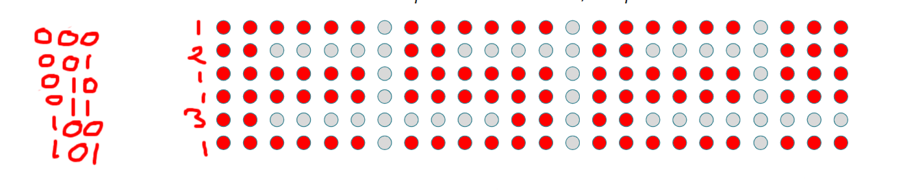

Week 4:

1. takes text input
2. calculates length of array (6 per letter/number, 2 per punctuation, 1 space between each character)
- Will need to be able to tell the difference between a normal character and a punctuation
3. combines premade arrays of the corresponding characters into the “master” array
4. array is printed row by row and if needed the text is scrolled

